New Zealand Green Building Council submission on Energy Efficiency Policy Options for Heat Pump Water Heaters

Thank you for the opportunity to make a submission on the Regulation Impact Statement for
Consultation: Energy Efficiency Policy Options for Heat Pump Water Heaters.

The New Zealand Green Building Council is supportive of the measures proposed but we argue they do not go nearly far enough to accelerate the uptake of heat pump water heater systems (HPWH). Greater use of HPWH would significantly reduce demand for natural gas/LPG and electricity at a time when the country is facing an energy crisis. Achieving this demand reduction would lower the cost of living for households, while also freeing up much-needed energy for industry, and helping to lower energy prices by improving the supply balance.

To this end, we recommend that, in addition to the Minimum Energy Performance Standards and information provision requirements laid out in Option 3, the Government should also pursue:
- Rebates for households and commercial building owners installing HPWH systems
- A move to all-electric buildings in line with Victoria
- Requiring demand flexibility devices to be installed on HPWH and electrical resistance systems

About the New Zealand Green Building Council
The New Zealand Green Building Council is the construction and building industries’ peak body for advocating for and delivering measures that support improved energy efficiency and sustainability in buildings.

Established in 2005 by 31 companies, we're grown to now have the backing of over 700 of the country’s leading engineers, architects, builders, developers, regulators, finance experts, and educators. Our members cover the supply chain, and deliver thousands of homes and buildings throughout the country.

Working with industry experts, NZGBC develops and administers New Zealand’s leading energy and environmental impact rating systems for buildings -Homestar, GreenStar, and NABERSNZ. These systems help developers, builders, investors, owners, renters, and lessees better understand the environmental sustainability of the buildings they deal with and how they can be improved.

Scale of hot water energy demand
EECA’s Energy End Use Database shows that households and commercial buildings use over 6PJ of natural gas and LPG for water heating in a year, 5% of current supply. This is equivalent to the total 2023 demand from Pulp, Paper, and Converted Paper Product manufacturing, Primary Metal and Metal Product manufacturing, and Non-Metallic Mineral Product manufacturing combined. As natural gas and LPG production continue to rapidly decline in the coming years, this 6PJ/yr will become of greater and greater significance.

Additionally, households and commercial buildings use 16.3PJ/4,500GWh of electricity for water heating (11% of electricity consumption), on par with the annual consumption of the Tiwai Point Smelter and greater the total annual electricity production from natural gas plants.

This energy use is very large and is also massively inefficient. HPWH are up to four times as efficient in terms of heat delivered for energy input as electrical resistance and gas hot water systems. Yet, the consultation paper notes that just 1% of water heaters in New Zealand are heat pumps and another 2% solar electric, with 65% of systems being electrical resistance and 24% being gas systems (with wood accounting for the other 8%).

Using EECA data, we have calculated that a full conversion of the electrical resistance and gas systems to HPWH would save 6PJ a year of natural gas/LPG and a net saving of 9.7PJ/2,700GWh per year of electricity. HPWH are so much more efficient that the extra electricity demand from replacing gas units with HPWH would be more than offset by the savings achieved by converting electrical resistance systems to HPWH.

Moreover, water heating energy demand is concentrated at peak demand periods. NZGBC analysis shows 46% of peak electricity demand comes from residential space and water heating. Peak demand drives transmission investment costs and the use of expensive natural gas and coal for electricity generation. Increased use of HPWH systems would meaningfully reduce demand peaks and associated costs.

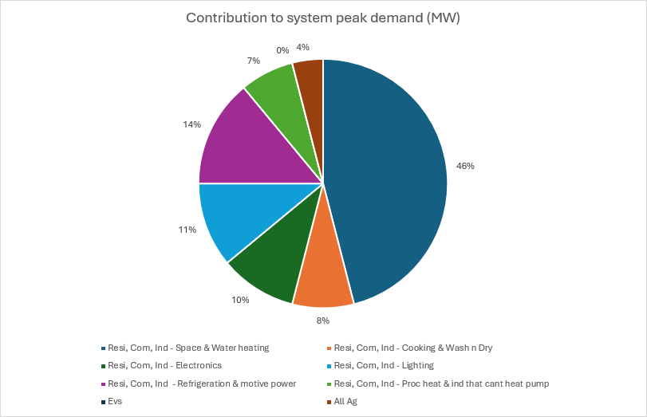

Current proposals insufficient
New Zealand ‘s energy crisis is destroying businesses and jobs, and costing households. In the past two years, households alone have seen their natural gas and electricity bills rise by $800m a year. New Zealand families are struggling to afford to heat under-insulated homes, while businesses are forced to pass on rising costs. Numerous factories have had to cut back production or close entirely in response to lack of natural gas supply or unaffordable prices for natural gas and electricity. Transpower has warned that there is an increased risk of electricity shortages during winter peaks, driven by heating of buildings.

The continued collapse of natural gas supply is unavoidable, and imports are uneconomic. Building sufficient new electricity generation to replace gas will be difficult, very expensive, and will add strain to the electricity network.

To relieve pressure on households, businesses, and the electricity network effective policies are needed that will free up energy.

In this context and given the scale of energy savings available from accelerated HPWH adoption, the proposals in the consultation document are manifestly inadequate.

NZGBC supports Option 3: Minimum Energy Performance Standards for HPWH from 2026 and voluntary information provision in 2026 and mandatory information provision in 2028. However, EECA’s modelling shows how little effect these moves would have. Option 3 delivers annual gas savings of just 0.1PJ and electricity savings of just 192GWh by 2040.

So much more can be done. And the Government only need to look to Australia for inspiration.

Following Victoria’s lead - rebates and ending gas sales
Australia has been far more successful in driving uptake of HPWH in recent years than New Zealand. The paper notes that HPWH systems account for 12% of hot water system sales in Australia currently, but only 2% in New Zealand.

Subsidies at both the federal and state levels decrease the capital cost differential of HPWH compared to electrical resistance and gas systems. Most notably, the $1,000 Victoria Solar rebate ($1,400 for locally manufactured units) is associated with the highest uptake of HPWH in the federation - with the consultation document showing Victoria accounts for nearly half of HPWH sales nationwide, despite having only a quarter of the country’s population.

In New Zealand, a third of consumers surveyed by EECA said they would be likely or very likely to install a HPWH system when replacing their old unit, but 76% said the cost was their top concern when buying a hot water system.

We estimate a $1,000 rebate on HPWH (decreasing the cost differential with old-fashioned systems by a third) would be adequate to address that cost concern for a significant number of households and unlock a significant amount of latent demand. A programme of 300,000 such HPWH rebates (enough for 1 in 6 homes) would save 0.9PJ a year of natural gas/LPG and a net 300GWh a year of electricity (assuming the HPWH systems displace gas and electrical resistance systems proportionally with current use). A similar scheme could be created for commercial building owners, with the rebate set in terms of KW of heating capacity of the HPWH unit(s) installed.

Additionally to financial incentives, Victoria is moving to essentially end the sale of gas hot water systems. From 2027, gas units in owner-occupied homes must be replaced with electric units at end of life, gas and electrical resistance units in rentals must be replaced with HPWH systems at end of life, and new buildings must be all-electric. This will make HPWH the default choice for new and replacement hot water systems.

The Victorian Building Electrification Regulations are projected to reduce residential and commercial buildings’ gas consumption by 80% by 2045. These savings, 102.1PJ a year by 2045, utterly dwarf the 3PJ per year of savings by 2040 that Option 3 of this consultation paper is expected to deliver for the entirety of Australia.

If applied to New Zealand, a similar 80% reduction in gas demand from hot water systems in residential and commercial buildings would deliver 5PJ a year of savings by 2045, compared to just 0.1PJ under Option 3 of the consultation.

Given this consultation has been developed in conjunction with the Australian Government, it is surprising that the lessons from the most successful Australian state have not been adopted and included as options.

Demand Flexibility
The paper discusses the benefits of coupling HPWH systems with demand flexibility units. A step up from ripple control, demand flexibility enables two-way communication between external parties (electricity suppliers/grid operators/lines companies) and the HPWH system to optimise heating times. This can reduce peak loads on the electricity grid and enable HPWH systems to function as effective batteries for rooftop solar electricity production on sunny days.

We do not understand why the paper does not consider this option in more depth. The Gridsmart trial in New Zealand has been successful. There is no need to delay years before considering policy around this technology while the rest of the world moves forwards. Indeed, the government should move to rapidly make it mandatory for new electric hot water systems to have demand flexibility devices. Now is the time for the government to act and develop standards before 1) different, incompatible approaches come to market and 2) the number of HPWH systems grows to a significant level.

Conclusion
There are very important energy savings to be realised by accelerating the adoption of HPWH systems and ensuring they are married with demand flexibility devices. The measures proposed in this consultation leave that potential unrealised. That is inadequate in the context of New Zealand’s energy crisis. In addition to the measures proposed, the government should also:
- Introduce rebates for household installing HPWH systems
- Follow Victoria’s lead in mandating steps towards all-electric buildings
- Require that HPWH and electrical resistance systems come with demand flexibility devices installed

https://www.eeca.govt.nz/assets/EECA-Resources/Research-papers-guides/Electrifying-Aotearoa-the-Consumer-Perspective-April-2024.pdf
https://engage.vic.gov.au/download/document/41370

